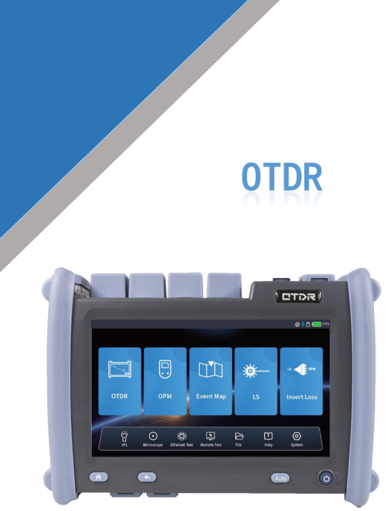

-

Quad-core processor, Linux system, smooth contro

令Themin event blind area is0.8m,the max dynamic rage is45

◆PON network splitter test, uuppto1/64support

Large storage capacity, internal storage>12GB

Generate pDF test and diagnosis report with one click

 Integrate oTDR/VFL/LS/OPM/Event Map/LOSS Test/End Face ldentifie/Ethernet Remote/Network test

|  |  |  |  |  |  |  |  |  |  |  |  |  |  |  |
| --- | --- | --- | --- | --- | --- | --- | --- | --- | --- | --- | --- | --- | --- | --- |
| **Model** | **OTDR** | | | | | | | | | | | | | |
| **S1** | **S2** | **D0** | **D1** | **D2** | **D3** | **D4** | **T1** | **T2** | **T3** | **T4** | **F1** | **M1** | **SM1** |
| **Type** | SM | | | | | | | | | | | | MM | SM/MM |
| **Wavelength** | 1650nm | | 1310/1550nm | | | | | 1310nm /1490nm /1550nm | 1310nm /1550nm /1625nm | | 1310nm /1550nm /1650nm | 1310nm /1490nm /1550nm /1625nm | 850nm /1300nm | 850nm /1300nm /1310nm /1550nm |
| **MaxDynamicRang**  **e(dB)** | 33 | 38 | 32/30 | 35/33 | 38/36 | 42/40 | 45/43 | 38/36/36 | 32/30/ 30 | 42/40 /40 | 42/40/40 | 37/35/ 35/35 | 28/26 | 26/28/35/ 33 |
| **Event Blind Zoneq** | 1m | | | | | 0.8m | | 0.8m | 1m | 0.8m | 0.8m | 1m | 1m | |
| **ATT Blind zone** | 5m | | | | | 4m | | 4m | 5m | 4m | 4m | 5m | 5m | |
| **Test Range** | 100m/500m/1.25km/2.5km/5km/10km/20km/40km/80km/125km/260km/420km | | | | | | | | | | | | | |
| **Pulse Width** | 3ns/5ns/10ns/20ns/30ns/50ns/80ns/100ns/200ns/300ns/500ns/800ns/1us/2us/3us/5us/8us/10us/20us | | | | | | | | | | | | | |
| **Ranging accuracy** | ±(0.75m+ Sample interval+0.005%×Test distance) | | | | | | | | | | | | | |
| **CLoss accuracy** | ±0.001dB | | | | | | | | | | | | | |
| **Max Sample Points** | ≥256K | | | | | | | | | | | | | |
| **Sample Resolution** | 0.05m~4m | | | | | | | | | | | | | |
| **Reflection Accuracy** | 0.03dB/dB | | | | | | | | | | | | | |
| **File Format** | SOR Standard File Format | | | | | | | | | | | | | |
| **Loss Analysis** | 4-point method /5-point method | | | | | | | | | | | | | |
| **Laser Safety Level** | Class ll | | | | | | | | | | | | | |
| **Data Storage** | ≥12GB | | | | | | | | | | | | | |
| **Connector** | FC/UPC (Interchangeable sc. ST) | | | | | | | | | | | | | |
| **Functions of Host** | OTDR/OPM/VFL/LS/Event Map/Fiber End Detection /Ooptical LossTest /Ethernet Remote/Network test | | | | | | | | | | | | | |

Event Map OTDR OPM

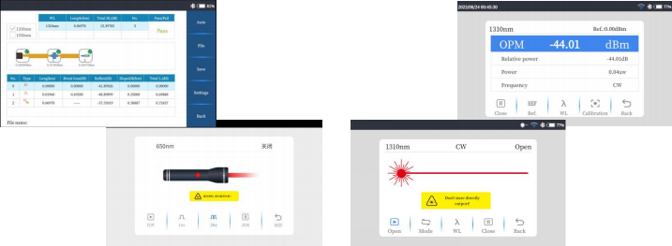VFL 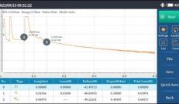LS